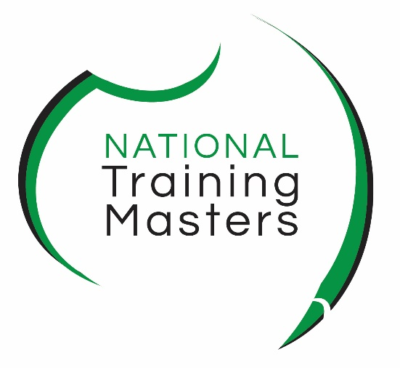 **ntm.edu.au**

LEARNER  
HANDBOOK

**2019**

 **business and management | whs | human resources | tae**

## Copyright 2016 ©

This handbook has been developed by and remains the property of the **National Training Masters (NTM)**. Unauthorised use is in breach of the Intellectual Property rights of this document and severe penalties may apply.

RTO Provider Number: **91284**

National Training Masters

Head Office

Level 1, 18 Manning Street

KIAMA NSW 2533

[www.ntm.edu.au](http://www.ntm.edu.au)

Phone: 1300 653 501

Email: [admin@ntm.edu.au](mailto:admin@ntm.edu.au)

Version Control

|  |  |  |  |
| --- | --- | --- | --- |
| Version # | Date | Reason | Author |
| 3.0 | 18 September 2015 | Re-formatting | Jane Lees |
| 4.0 | 2 May 2016 | Audit | David Michal Lipták |
| 4.1 | 19 January 2017 | Update Version Control and Year to 2017 | Mia Wingrove |
| 4.2 | 28 July 2017 | Minor addition made to refund policy | Jane Lees |
| 4.3 | 23 November 2017 | Update version control and year to 2018, add new course | Jane Lees |
| 4.4 | 04 December 2017 | Update course code | Jane Lees |
| 4.5 | 09 January 2018 | Change Richmond address | Jane Lees |
| 4.6 | 28 March 2018 | Sentence added on page 7 | Jane Lees |
| 4.7 | 14 June 2018 | TAE40116 added to list of qualifications, email changed pages 7 and 9 | Jane Lees |
| 4.8 | 21 August 2018 | Address changed, CII Animal Studies added | Jane Lees |
| 4.9 | 09 January 2019 | change date on front cover, update course numbers | Jane Lees |

TABLE OF CONTENTS

Administration 6

Assessment appeal 7

Australian Qualifications Framework (AQF) 7

Career development and counselling 8

Certificates 8

Complaints 9

Discrimination 9

Feedback 9

Harassment and bullying 10

Privacy 10

Reasonable Adjustment 10

Recognition of prior learning 12

Refund policy 12

Rights and responsibilities 13

Training packages 13

Unique Student Identifier 14

What is competency based training? 14

ABOUT US

We welcome you to National Training Masters (NTM) and thank you for studying with us.

We are a boutique Registered Training Organisation (RTO) with our headquarters in Kiama on the beautiful South Coast of NSW. We also have an office in Richmond, NSW to service our clients in Western Sydney and we deliver nationally accredited training in all states of Australia.

RTOs are training providers registered by the national regulator, ASQA (Australian Skills Quality Authority) to deliver vocational education and training (VET) courses. RTOs can be private training companies (such as National Training Masters), TAFE colleges, adult community colleges or companies. RTOs deliver nationally recognised qualifications according to their scope of delivery.

OUR COURSES

Courses we currently deliver are:

|  |  |
| --- | --- |
| ACM20117 | Certificate II in Animal Studies |
| BSB40215 | Certificate IV in Business |
| BSB42015 | Certificate IV in Leadership and Management |
| BSB41415 | Certificate IV in Work Health and Safety |
| BSB41015 | Certificate IV in Human Resources |
| BSB41515 | Certificate IV in Project Management Practice |
| BSB50215 | Diploma of Business |
| BSB50415 | Diploma of Business Administration |
| BSB50618 | Diploma of Human Resources Management |
| BSB51315 | Diploma of Work Health and Safety |
| BSB51918 | Diploma of Leadership and Management |
| TAE40116 | Certificate IV in Training and Assessment |

We deliver training to both the general public and to corporate clients. We specialise in contextualising our resources to clients’ workplaces so that training is relevant, practical and engaging. We recognise that people undertaking courses have busy lives and we offer a range of training options to fit in with your lifestyle. Classes are regularly held at both our Kiama and Richmond training rooms, at your workplace, or you can choose a variety of flexible delivery options including fully online, self-paced, or intensive one-on-one training if you need a qualification in a hurry. Whichever method of study you choose, you will always have the support of our dedicated team of people.

HOW TO CONTACT US

**Head Office: New South Wales - Illawarra**

Street address: Level 1, 18 Manning St, Kiama, NSW 2533

Postal address: PO Box 4225, Pitt Town, NSW 2756

Phone: 1300 653 501

Email: [admin@ntm.edu.au](mailto:admin@ntm.edu.au)

Website: [www.ntm.edu.au](http://www.ntm.edu.au)

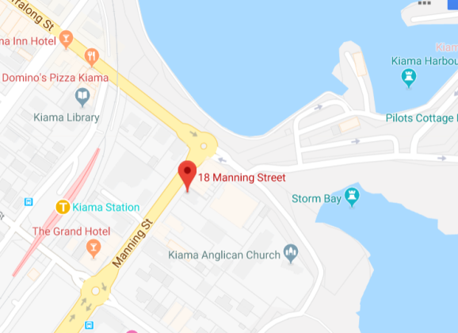

**Western Sydney Office:** “Toxana Business Centre”, 147 Windsor St, Richmond, NSW 2753

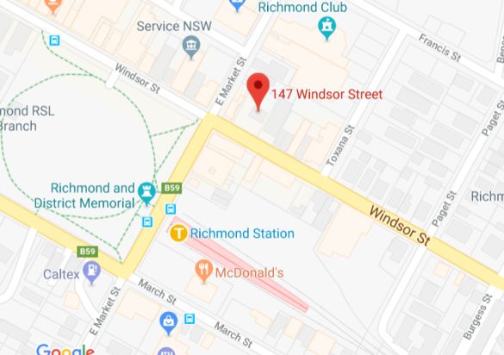

**Please direct all enquiries to the Kiama office.**

CODE OF PRACTICE

Our Code of Practice sets out our commitment to act with absolute integrity and maintain the highest possible standards in providing you with vocational education and training. It incorporates the following elements which underpin our policies and procedures.

## administration

National Training Masters complies with all necessary Federal and State legislation, including but not limited to the following:

* Standards for Registered Training Organisations 2015 (SNR)
* National Vocational Education and Training Regulator Act 2011 (NVR)
* Work Health and Safety Act 2011 (WHS)

The [Standards for Registered Training Organisations 2015](http://www.comlaw.gov.au/Details/F2014L01377) are a set of standards which all RTOs must follow to ensure nationally consistent, high-quality training across Australia’s VET system.

The [National Vocational Education and Training Regulator Act 2011](http://www.comlaw.gov.au/Series/C2011A00012) was established to provide for the registration of training organisations and the accreditation of vocational courses in accordance with national standards. The objects of the Act are:

* to provide for the registration of people and organisations that conduct vocational courses
* to provide for the approval of people and organisations (other than official universities) that provide courses to overseas students
* to promote consistency of standards in vocational education and training

The [Work Health and Safety Act 2011](https://www.comlaw.gov.au/Details/C2015C00472) provides a framework to protect the health,  safety and welfare of all workers at work, all other people who might be affected by the work, and for the general public so that their health and safety is not placed at risk by work activities.

Other legislation we adhere to includes:

* Privacy Act 1988
* Anti-Discrimination Act 1991
* Copyright Act 1968
* Equal Employment Opportunity Act 1987
* Racial Discrimination Act 1975
* Disability Discrimination Act 1992
* Age Discrimination Act 2004
* Fair Work Act 2009

## assessment appeal

As a learner, you have the right to appeal against a decision made in regards to the final assessment result if:

* you have been assessed as Not Yet Competent (NYC) in an assessment against specific competency standards
* you believe you have sufficient grounds and evidence entitling you to be assessed as competent (C) or granted Recognition of Prior Learning (RPL), if applicable
* you are able to adequately demonstrate that you have the skills and experience to be able to meet the learning outcomes of units you are appealing against.

It is best to speak to your trainer/assessor first to resolve any issues regarding your assessments and results. If you are still not satisfied with the outcome, you must appeal in writing within 10 working days of receiving the result. It is important to detail the grounds of your appeal, provide a copy of any feedback and the result/s from your trainer/assessor to [admin@ntm.edu.au](mailto:admin@ntm.edu.au). You will receive a confirmation e-mail regarding the registration of your complaint and the delegate responsible for the appeals process. Within 20 working days you will receive the outcome of your appeal.

## australian qualifications framework (Aqf)

The AQF is a nationally agreed framework which identifies the qualifications available in three sectors of education: schools, vocational education and training and higher education sectors in Australia.

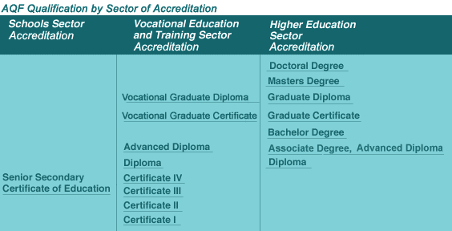

[www.aqf.edu.au](http://www.aqf.edu.au)

Some kinds of qualification are issued by more than one kind of institution, eg Diplomas, Advanced Diplomas, Associate degrees and Bachelor degrees can be offered by both vocational education training providers and universities. AQF qualifications are used throughout Australia and have been developed in conjunction with both industry and the community. Each qualification is based on the level of outcome and not on the length of the course. All of the AQF qualifications offered by National Training Masters are nationally recognised.

## career development and counselling

All students have access to a qualified Career Development Practitioner who can assist with career planning, resume writing, job seeking, recognition of prior learning and assessment of overseas qualifications. Students also have access to a registered psychologist who can assist with personal counselling directly affecting their studies, such as learning difficulties, anxiety, study planning and help in referring to outside agencies. To access career development and counselling services please call our national office to make an appointment. These support services are free to enrolled students.

## certificates

Two different kinds of certificates are awarded at National Training Masters. They are:

**Certificate of Qualification**– identifies the student as having passed all the course requirements and indicates that the student has completed the whole qualification. You will receive a certificate (testamur) stating which qualification you have earned as well as a list of all the units you completed within that qualification (transcript).

**Statement of Attainment** – identifies the student as having completed some, but not all competencies in a qualification. The Statement of Attainment will list which individual competencies you have completed.

Certificates are normally issued as soon as a student has successfully completed all their units of study, and after all fees have been paid in full.

## complaints

We do everything we can to ensure our customers’ satisfaction and accept that sometimes issues come up. If any issue arises that you believe is impacting your study, please follow our procedures to help resolve it:

1 try to resolve the issue with the person concerned, eg your trainer

2 if this is not successful, please notify the Office Coordinator by email [admin@ntm.edu](mailto:admin@ntm.edu).au and she will attempt to resolve the issue

3 if you are still not satisfied, the complaint will be reviewed by the Chief Executive Officer

4 if a complaint cannot be resolved internally an independent third party will be called on to review the complaint or appeal

All of our staff are approachable and have your best interests and welfare at heart, so we encourage you to talk to them in the first instance and not let minor matters become larger ones. We have designed our complaints and appeals policy to be as simple and straightforward as possible.

## discrimination

National Training Masters is committed to providing a training environment where participants feel valued and safe. We do not tolerate any form of discrimination, bullying, harassment or intimidation either by or against our staff and students.

All our staff and learners have an obligation under NSW legislation not to discriminate, treat unfairly or harass people because of who they are, who they are related to, or who they associate with on any of the following grounds:

* sex, including pregnancy
* marital status
* race, colour, ethnic or ethno-religious background descent or nationality
* disability, including intellectual, physical, psychiatric and HIV/AIDS
* sexual orientation
* age

It is also unlawful for a person to do anything publicly that could incite vilification, encourage or stir up hatred, serious contempt or severe ridicule against others on any grounds.

## Feedback

We value your feedback about your learning experience. Please feel free to give us feedback on the learning materials, assessments, your trainer/assessor, staff and the training venue, to [admin@ntm.edu.au](mailto:admin@ntm.edu.au). Our quality assurance team will get back to you within 10 working days.

## harassment and bullying

Bullying is a form of violence and occurs if:

* a person or group of people repeatedly act unreasonably towards a worker or a group of workers
* the behaviour creates a risk to health and safety

Unreasonable behaviour includes victimising, humiliating, intimidating or threatening. Whether a behaviour is unreasonable can depend on whether a reasonable person might see the behaviour as unreasonable in the circumstances. Examples of bullying include:

* teasing or practical jokes
* behaving aggressively
* pressuring someone to behave inappropriately
* excluding someone from work-related events or
* unreasonable work demands

(Source: [www.fairwork.gov.au](http://www.fairwork.gov.au))

Harassment is behaviour that is directed at an individual or groups and which is offensive, belittling, humiliating, intimidating or threatening and is unwelcome and unsolicited and is of a type that is usually unreciprocated, expected to be repeated, makes the work or study environment unpleasant, humiliating or intimidating for the individual or group. It can be sexual in nature or based on gender, race, disability, sexual preference or a range of other factors.

Any student who believes they are being discriminated against, bullied or harassed should follow our Complaints Procedure to ensure we can deal with the problem. You have the right to feel safe while you are training with us and our focus is on providing an environment where this can happen.

## privacy

National Training Masters complies with the Privacy Act 1988. We only collect personal information necessary for your enrolment and study records. These records are kept confidential at all times and are not disclosed to other parties without your written approval, except for the information that is required for data reporting to the national regulator (ASQA) and the National Centre for Vocational Education Research (NCVER). As a learner you may seek an application to view your student records by contacting Administration, in person at our Head Office in Kiama, call or email [admin@ntm.edu.au](mailto:admin@ntm.edu.au) to make an appointment.

REASONABLE ADJUSTMENT

If you have a disability, health or medical condition such as a learning difficulty, physical, mental health, neurological, vision, hearing or other impairment, National Training Masters offers a range of training and assessment strategies to meet your individual needs. To make an appointment with our Learning Consultant to discuss support options contact our national office. National Training Masters adheres to the Disability Standards for Education 2005 and the Disability Discrimination Act 1992.   
  
If you have any Language (speaking), Literacy (reading) and Numeracy (maths) LLN issues, or English as a Further Language (EFL), National Training Masters is here to help you with a range of support strategies. Please contact our national office to make an appointment with our Learning Consultant.

## recognition of prior learning

You may be eligible to receive recognition for some or all of the units in your course of study, either through credit transfer or through recognition of prior learning (RPL).

Credit transfer means you have completed a single unit, or multiple units, from a nationally recognised training package through a registered training organisation (RTO). This could be a TAFE college, a community college or a private RTO. All you need to do is provide us with a copy of your transcript showing the unit(s) you have completed and a request for a credit transfer.

If you have not previously studied but believe you have the skills and knowledge from your current or previous job role, or from life experience, please talk to us about the RPL process, which may involve producing a portfolio of evidence, being assessed in your workplace, demonstrating particular skills or undertaking a professional conversation with a trainer. Being granted RPL or a credit transfer can help you complete your qualification faster and means you don’t have to spend time studying a subject you already know.

You may apply for RPL or credit for a single unit of competency or groups of competencies up to 100% of a qualification.

## refund policy

Students who cancel their enrolment in a face-to-face course are entitled to the following refunds:

If cancelled more than five (5) business days before the scheduled course start date, students will receive a refund of money paid less a cancellation fee of $50. If at the time of cancellation the student opts to transfer to the same course at a later date the cancellation fee will not be charged.

If cancelled during the last five (5) business days before the scheduled course start date, students will receive a refund of money paid less a cancellation fee of $100. If at the time of cancellation the student opts to transfer to the same course at a later date the cancellation fee will not be charged.

If a student does not cancel their face-to-face course enrolment prior to the commencement of the course they are not entitled to any refund and the full course price will be payable. If the student submits a new course enrolment they will be required to pay the full course price for the new enrolment.

If a student withdraws after the course has started and they have attended classes, there is no refund.

Please note that all cancellations must be in writing on our official withdrawal form which the Office Coordinator can supply to you.

If National Training Masters has to cancel or reschedule a course, students will be offered the opportunity to join the new course or receive a full refund of money.

## rights and responsibilities

As a learner you have the right to:

* be treated fairly and respectfully by our staff and other learners
* learn in an environment free of discrimination and harassment
* have your records and confidential information kept private
* apply for recognition of prior learning
* lodge a complaint without fear of retaliation or victimisation

As a learner you are expected to:

* treat other learners and staff with respect and fairness
* ensure that all assessment events are your own work
* observe any required safety practices, eg wear approved clothing and PPE
* catch up on any missed work due to absence
* behave responsibly by not:
  + harassing, threatening or bullying fellow learners or staff
  + being under the influence of alcohol or drugs
  + engaging in any other behaviour which could offend, embarrass or threaten others

## 

## training packages

Training packages are developed by Skills Service Organisations (SSOs) to meet the training needs of an industry, or a group of industries. They specify the skills and knowledge required to perform effectively in the workplace but do not suggest how a learner should be trained or the length of time taken. This means that participants may complete their qualification in different amounts of time depending, for example, on the amount of related workplace experience.

Each training package is made up of three components:

* Units of competency: define the skills and knowledge to operate effectively and how they need to be applied to perform effectively in a workplace context.
* Qualifications framework: groups of units of competency ranging from Certificate I to Graduate Diploma level.
* Assessment guidelines: the industry's preferred approach to assessment, including the qualifications required by assessors, the design of assessment processes and how assessments should be conducted.

Only registered training organisations (RTOs) or organisations working in partnership with an RTO are authorised to deliver training packages qualifications and units of competency, if the RTO has the training package product/s on their scope of registration.

## unique student identifier

From 1 January 2015, all students doing nationally recognised training need to have a Unique Student Identifier (USI).

A USI is a reference number made up of numbers and letters. [Creating a USI](http://www.usi.gov.au/create-your-USI) is free. It creates a secure online record of your nationally recognised training that you can access anytime and anywhere, and it’s yours for life.

The USI is linked to the National Vocational Education and Training (VET) Data Collection, and this means an individual’s nationally recognised training and qualifications gained anywhere in Australia, from different training organisations, will be kept all together.

The USI will:

* + link a student's VET achievements, regardless of where in Australia they did the course
  + let students easily access secure digital transcripts of their achievements (transcripts will be available from January 2016)
  + give students more control over their VET information

Please click on the link below and keep a record of your USI which you will need to provide when you enrol with us.

<http://www.usi.gov.au/create-your-USI/Pages/default.aspx>

## what is competency based training?

Competency Based Training (CBT) is training that develops the required skills, knowledge and attitudes to meet the competency standards that are set out in national Training Packages.

It is an approach to learning where emphasis is placed on what a learner can do in the workplace as a result of their training. Learners who have successfully achieved competency will have the performance and knowledge they need to complete workplace activities in a range of different situations and environments, to an industry standard of performance that is expected in the workplace. Learners who are not yet competent have the opportunity to retake assessment events or provide further evidence to demonstrate competency while they are enrolled and financial with National Training Masters. Contact your trainer/assessor for details on extensions and resubmission of assessment events.

Competency based training is usually based on performance standards that have been set by industry. Competency based assessment materials are designed to ensure that each learner has achieved all the outcomes (performance and knowledge) required by each unit of competency. Competency based training allows for flexible entry and exit for learners enabling them to complete their studies much quicker. Once they have achieved competency in one unit, they can then move onto the next unit. Training can take place both on and off-the-job using a variety of delivery modes and methods.