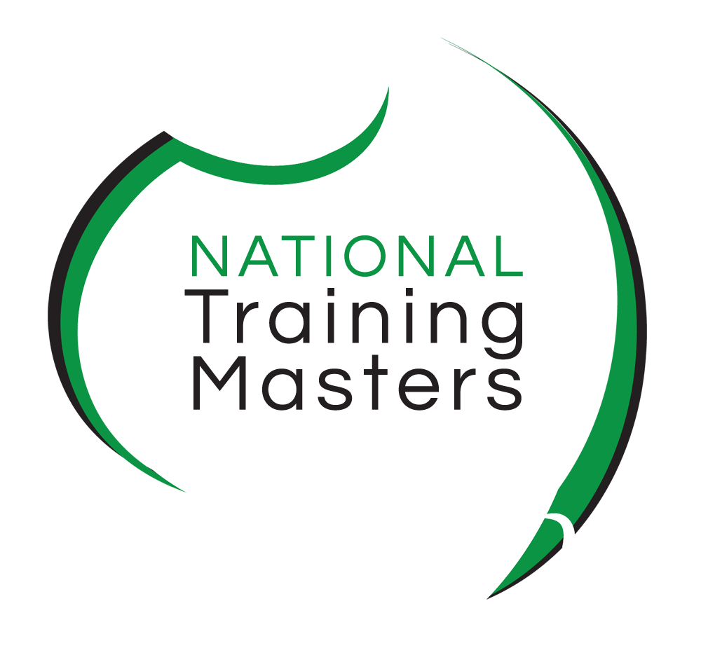
Enrolment Form - Gap training workshops
TAE40116 Certificate IV in Training and Assessment
Transition 2019
Please check the workshops and units(s) of competency you are enrolling in, all workshops are held at either our Kiama or Richmond campus:. You may enroll in one or more workshops. Simply select your date and location by choosing an item:
☐ TAEASS502 Design and develop assessment tools - Statement of Attainment
Select your date and location: Choose an item.
☐ TAELLN411 Address language, literacy & numeracy skills – Statement of Attainment
Select your date and location: Choose an item.
☐ TAEASS401 Plan assessment activities & process & TAEASS403 Participate in assessment validation - Gap Training
(You must have a complete TAE40110 Certificate IV in Training and Assessment, the unit TAELLN411 / TAELLN401A & workshop 1 or already hold the unit TAEASS502A / B, you will be sent a mapping kit before the workshop. Once you have completed the three units you will then be eligible to transition to the new TAE4016 Certificate IV in Training and Assessment at no cost)
Select your date and location: Choose an item.

SECTION 1 – STUDENT DETAILS Sections marked with * must be completed

Please PRINT clearly as this is how it will appear on your certificate. Please ensure that your details match with those of your Unique Student Identifier (USI). You must have a USI before you enrol, if you do not have one, visit: www.usi.gov.au to obtain your USI.

Use the check boxes to indicate your responses ().

*Title Choose an item. |  |  |  |  | *First Name Click or tap here to enter text. |  |  |  |  | * Surname Click here to enter text.
* Gender |  | Choose an item. |  |  |  | *DOB | Day |  | Choose an item. |  | Month | Choose an item. | Year | Choose an item.
* Email address |  |  | Click here to enter text.
*Phone no |  |  |  | Click here to enter text.
* Residential address - Street number and name
Click here to enter text.
Suburb | Click here to enter text.
Postcode | Click here to enter text. |  |  |  |  | State |  | Choose an item.
Identification
Please provide details for one of the forms of identity below.
Please ensure that the name written above is exactly the same as written in the document you provide to us.
Choose an item.
* Unique Student Identifier:
From 1 January 2015, National Training Masters can be prevented from issuing you with a nationally recognised VET qualification or statement of attainment when you complete your course if you do not have a Unique Student Identifier (USI). If you have not yet obtained a USI you can apply for it directly at www.usi.gov.au on a computer or mobile device
Enter your USI here Click or tap here to enter text.

SECTION 2 – EMPLOYMENT & CURRENT STUDY
* Which of the following best describes your current employment and current study status? (select one only)
☐ Full-time employee ☐ Employed - unpaid worker in a family business
☐ Unemployed - seeking full-time employment ☐ Unemployed - seeking part-time or casual work
☐ Not employed - not seeking employment ☐ Part-time or casual employee
☐ Self-employed - not employing others ☐ Employer

SECTION 3 - LANGUAGE & CULTURE
* In which country were you born?  ☐ Australia  ☐ Other nationality (if not Australian):  Click or tap here to enter text. | * Do you speak a language other than English at home?  ☐ No  ☐ Yes (please specify): Click or tap here to enter text.
* How well do you speak English? (if you answered ‘yes’ to previous question)  ☐ Very well  ☐ Well ☐ Not well | * Are you of Aboriginal or Torres Strait Islander origin?  ☐ No  ☐ Yes, Aboriginal  ☐ Yes, Torres Strait Islander
SECTION 4 - EDUCATION
* What is the highest level of schooling you have completed?  ☐ Year 12 or equivalent  ☐ Year 11 or equivalent  ☐ Year 10 or equivalent  ☐ Year 9 or equivalent  ☐ Year 8 or below  ☐ I am still attending school  * What year did you complete that level of schooling?  Click here to enter text. | * Have you completed any of the following qualifications:  ☐ No  ☐ Yes (please tick any applicable boxes)  ☐ Bachelor degree or higher  ☐ Advanced diploma or Associate degree  ☐ Diploma or Associate diploma  ☐ Certificate IV or Advanced certificate/technician  ☐ Certificate III or trade certificate  ☐ Certificate II  ☐ Certificate 1
SECTION 5 - DISABILITY
* Do you consider that you have a disability?  ☐ No (continue to Section 6)  ☐ Yes  If you selected YES, do you require extra support with your study?  ☐ No  ☐ Yes (please indicate type of support)  Click here to enter text. | * If you selected yes, please indicate which area?  ☐ Hearing/deaf  ☐ Physical  ☐ Intellectual  ☐ Learning  ☐ Mental health  ☐ Acquired brain injury  ☐ Vision  ☐ Medical condition, including chronic health conditions  ☐ Other: Click here to enter text.

SECTION 6 - REASON FOR STUDY
* Which of the following best describes your main reason for studying this course (select one only)  ☐ To get a job  ☐ To get a promotion  ☐ To develop extra skills for my job  ☐ It’s a requirement of my job  ☐ To start my own business | ☐ To develop my current business  ☐ To change careers  ☐ It’s a pre-requisite for another course I want to do  ☐ For personal interest  ☐ Other (please detail) Click here to enter text.

SECTION 7 - ACKNOWLEDGEMENT
☐ * I acknowledge that it is a condition of my enrolment that I abide by all National Training Masters policies and procedures. I hereby acknowledge that I have received and read the Learner Handbook, the Privacy Notice and Student declaration. I further acknowledge that when I enroll in a course with National Training Masters I may receive their regular email newsletter containing articles relevant to training as well as special enrolment offers from time to time. I may opt out from receiving these newsletters at any time.
Opt out here ☐

Signature:________________________________________ Date: Click or tap to enter a date.
If enrolling electronically select digital signature and enter your e-mail address.
☐ Digital signature enter your e-mail address:

SECTION 8 – PAYMENT ARRANGEMENT Please select your preferred payment option
Select your workshops: ☐ Workshop 1 TAEASS502 $350 ☐ Workshop 2 TAELLN411 $300
☐ Workshop 3 Gap Training TAEASS401 & TAEASS403 $400 ☐ All TAEASS502 + TAELLN411 + Gap $900
☐ Raise an invoice for my employer: insert business name
☐ I would like a payment plan ☐ Cheque (payable to Bombohill Pty Ltd)
☐ I would like to pay by direct deposit* ☐ Visa or ☐ MasterCard
Direct Transfer Bank details: Card number:_________________________________
BSB: 062 562 Expiry date: _____ /_____ CCV: __________
Account no: 1014 3287 Name of card holder:___________________________
Account Name: Bombohill Pty Ltd Signature:____________________________________
Reference: your name ☐ pay at our Head Office: Level 1, 18 Manning Street,
* preferred method of payment KIAMA NSW 2553 or call 1300 653 501

Office Use Only

Student ID #
Invoice #
Certificate #

* PLEASE NOW READ THE PRIVACY NOTICE AND STUDENT DECLARATION Before signing section 7 Acknowledgement

National Training Masters
Privacy Notice and Student Declaration

Before signing the enrolment form, take the time to read the terms and conditions of your enrolment contained in this declaration. Ensure you have read the Learner Handbook, containing a summary of all our policies and procedures.

Privacy Note

Under the Data Provision Requirements 2012, National Training Masters (NTM) is required to collect personal information about you and to disclose that personal information to the National Centre for Vocational Education Research Ltd (NCVER).

Your personal information (including the personal information contained on this enrolment form and your training activity data) may be used or disclosed by National Training Masters for statistical, regulatory and research purposes. National Training Masters may disclose your personal information for these purposes to third parties, including:
• School – if you are a secondary student undertaking VET, including a school-based apprenticeship or traineeship;
• Employer – if you are enrolled in training paid by your employer;
• Commonwealth and State or Territory government departments and authorised agencies;
• NCVER
• Organisations conducting student surveys; and
• Researchers.

Personal information disclosed to NCVER may be used or disclosed for the following purposes:
• Issuing statements of attainment or qualification, and populating authenticated VET transcripts;
• facilitating statistics and research relating to education, including surveys;
• understanding how the VET market operates, for policy, workforce planning and consumer information; and
• administering VET, including programme administration, regulation, monitoring and evaluation.

You may receive an NCVER student survey which may be administered by an NCVER employee, agent or third-party contractor. You may opt out of the survey at the time of being contacted.

NCVER will collect, hold, use and disclose your personal information in accordance with the Privacy Act 1988 (Cth), the VET Data Policy and all NCVER policies and protocols (including those published on NCVER’s website at www.ncver.edu.au).

Student Declaration and Consent
I declare that the information I have provided to the best of my knowledge is true and correct. I consent to the collection, use and disclosure of my personal information in accordance with the Privacy Notice above.

