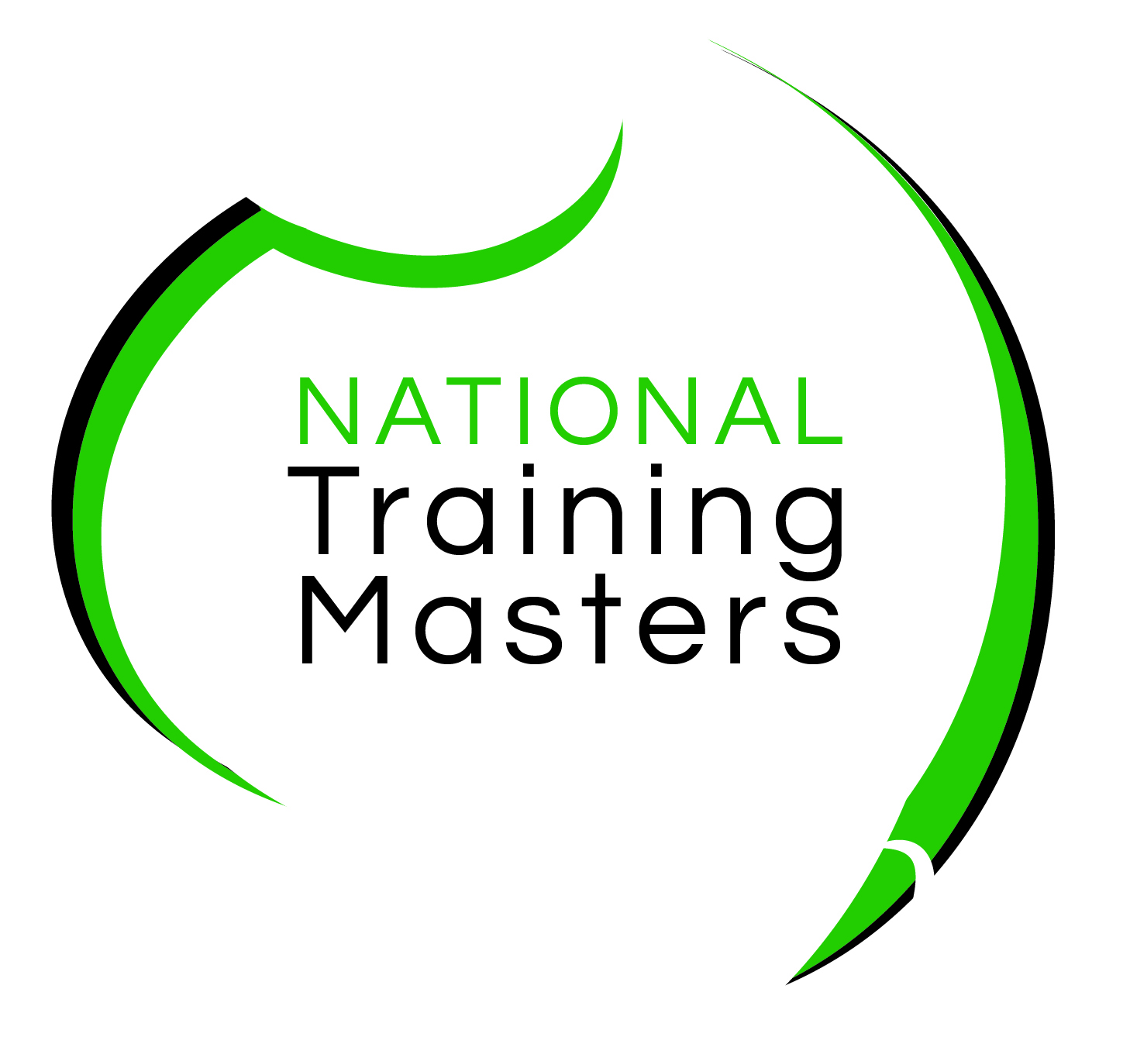**National Training Masters**

Enrolment Form 2022

**ACM20121 Certificate II in Animal Care**

**ACM30321 Certificate III in Wildlife and Exhibited Animal Care**

**ACM30122 Certificate III in Animal Care Services**

**SECTION 1 – STUDENT DETAILS**

***Sections marked with * must be completed***

Please **PRINT** clearly as this is how it will appear on your certificate. Please ensure that your details match with those of your Unique Student Identifier (USI). You must have a USI before you enrol, if you do not have one, visit: [www.usi.gov.au](https://www.usi.gov.au/students/create-your-usi/) to obtain your USI. Use the check boxes to indicate your responses (⌧).

|  |  |  |  |  |  |  |  |  |  |  |
| --- | --- | --- | --- | --- | --- | --- | --- | --- | --- | --- |
| *Title: | | **\***First Name | | | | | | **\*** Surname | | |
| **\*** Gender:  Male  Female  Other | | | | **\***DOB | | *(day)* | | *(month)* | | *(year)* |
| **\*** Email address | | |  | | | | | | | |
| **\***Phone no *(student mobile)* | | | | | | | | *(Student Home)* | | |
| **\*** Residential address - Street number and name | | | | | | | | | | |
| * Suburb |  | | | | | | *State | | *Postcode | |
| **Identification** (You must provide proof of identity below):  Please ensure the name that is written in ‘**Student Details’** above is exactly the same in the documents you provide.   1. Drivers Licence 2. Medicare Card: Card Number.................... Individual reference .Choose an item...   Please select card colour: ☐ Green Expiry date ...................(MM/YYYY)  ☐ Yellow ☐ Blue Expiry date....................(DD/MM/YYYY)  *A minor need only supply a Medicare Card*  A copy of your identification is to be included; this may be a photo or PDF copy.  Send to[**admin@ntm.edu.au**](mailto:admin@ntm.edu.au)  **Identification documentation is required to verify your residency in NSW, citizenship, permanent residency, New Zealand citizenship or refugee status within Australia.** | | | | | | | | | | |
| **\*Unique Student Identifier**  From 1 January 2015, National Training Masters can be prevented from issuing you with a nationally recognised VET qualification or statement of attainment when you complete your course if you do not have a Unique Student Identifier (USI). If you have not yet obtained a USI you can apply for it directly at [www.usi.gov.au](https://www.usi.gov.au/students/create-your-usi/) on a computer or mobile device  **Enter your USI here**: | | | | | | | | | | |
| **SECTION 2 – EMPLOYMENT and CURRENT STUDY** | | | | | | | | | | |
| **\*** Which of the following best describes your current employment and current study status?  *(select one only)*  Full-time employee  Unemployed - seeking full-time employment  Part-time or casual employee  Unemployed - seeking part-time or casual work  Self-employed - not employing others  Not employed - not seeking employment  Employer  Employed - unpaid worker in a family business | | | | | | | | | | |
| **SECTION 3 - LANGUAGE and CULTURE** | | | | | | | | | | | |
| **\*** In which country were you born?  Australia  Other(please specify):  **\*** What is your citizenship? | | | | | **\*** Do you speak a language other than English at home?  No  Yes (please specify): ______________  **If you ticked ‘Yes’**  **\*** How well do you speak English?  Very well  Well  Not well | | | | | | |
| **\*** Are you of Aboriginal or Torres Strait Islander origin?  No  Yes, Aboriginal  Yes, Torres Strait Islander | | | | | | | | | | | |
| **SECTION 4 - EDUCATION** | | | | | | | | | | | |
| **\*** What is the highest level of schooling you have completed?  Year 12 or equivalent  Year 11 or equivalent  Year 10 or equivalent  Year 9 or equivalent  Year 8 or below  I am still attending school | | | | | **\*** Have you **completed** any of the following **qualifications**:  No  Yes (please tick any applicable boxes)  Bachelor degree or higher  Advanced diploma or Associate degree  Diploma or Associate diploma  Certificate IV or Advanced certificate/technician  Certificate III or trade certificate  Certificate II  Certificate I | | | | | | |
| **SECTION 5 - DISABILITY** | | | | | | | | | | | |
| **\*** Do you consider that you have a **disability**?  No (continue to Section 6)  Yes  If you selected **YES**, do you require **extra support** with your study?  No  Yes *(please indicate type of support)* | | | | | **\*** If you selected yes, please indicate which area?  Hearing/deaf  Physical  Intellectual  Learning  Mental health  Acquired brain injury  Vision  Medical condition, including chronic health conditions  Other: _________________________ | | | | | | |

|  |  |
| --- | --- |
| **SECTION 6 - REASON FOR STUDY** | |
| **\*** Which of the following best describes your main **reason for studying** this course  *(select one only)*  To get a job  To get a promotion  To develop extra skills for my job  It’s a requirement of my job  To start my own business | To develop my current business  To change careers  It’s a pre-requisite for another course I want to do  For personal interest  To get skills for community/voluntary work  Other (please explain) |

**ASSISTANCE WITH ENROLMENT**

If you would like any assistance with enrolment, payment options or would like to speak to a learning consultant, please contact us, details below:

**Head Office**: Level 1, 47 Manning Street, Kiama NSW 2533

**Telephone:** 1300 653 501

**web:** [www.ntm.edu.au](http://www.ntm.edu.au)

**e-mail:** [admin@ntm.edu.au](mailto:admin@ntm.edu.au)  
**Mail:** PO Box 4225, Pitt Town NSW 2756

**\***

**PLEASE READ THE PRIVACY NOTICE AND STUDENT DECLARATION AND**

**SIGN SECTION 7 - ACKNOWLEDGEMENT**

**National Training Masters**   
**Privacy Notice and Student Declaration**

Before signing the enrolment form, take the time to read the terms and conditions of your enrolment contained in this declaration. Ensure you have read the Learner Handbook, containing a summary of all our policies and procedures.

**Privacy Note**

Under the [Data Provision Requirements 2012](https://www.legislation.gov.au/Details/F2013L00160), National Training Masters is required to collect personal information about you and to disclose that personal information to the [National Centre for Vocational Education Research](http://www.ncver.edu.au) Ltd (NCVER).

Your personal information (including the personal information contained on this enrolment form and your training activity data) may be used or disclosed by National Training Masters for statistical, regulatory and research purposes. National Training Masters may disclose your personal information for these purposes to third parties, including:

* School – if you are a secondary student undertaking VET, including a school-based apprenticeship or traineeship;
* Employer – if you are enrolled in training paid by your employer;
* Commonwealth and State or Territory government departments and authorised agencies;
* NCVER
* Organisations conducting student surveys; and
* Researchers.

Personal information disclosed to NCVER may be used or disclosed for the following purposes:

* Issuing statements of attainment or qualification, and populating authenticated VET transcripts;
* facilitating statistics and research relating to education, including surveys;
* understanding how the VET market operates, for policy, workforce planning and consumer information; and
* administering VET, including programme administration, regulation, monitoring and evaluation.

You may receive an NCVER student survey which may be administered by an NCVER employee, agent or third-party contractor. You may opt out of the survey at the time of being contacted.

NCVER will collect, hold, use and disclose your personal information in accordance with the *Privacy Act 1988* (Cth), the *VET Data Policy* and all NCVER policies and protocols (including those published on NCVER’s website at [www.ncver.edu.au](http://www.ncver.edu.au)).

**Student Declaration and Consent**

I declare that the information I have provided to the best of my knowledge is true and correct. I consent to the collection, use and disclosure of my personal information in accordance with the *Privacy Notice* above

**SECTION 7 - ACKNOWLEDGEMENT**

**\*** I acknowledge that it is a condition of my enrolment that I abide by all National Training Masters policies and procedures. I hereby acknowledge that I have received and read the Learner Handbook, the Privacy Notice, the Request for Payment and Student Declaration information. I further acknowledge that when I enroll in a course with National Training Masters I may receive their regular email newsletter containing articles relevant to training as well as special enrolment offers from time to time. I may opt out from receiving these newsletters at any time. I declare that the information I have provided to the best of my knowledge is true and correct. I consent to the collection, use and disclosure of my personal information in accordance with the *Privacy Notice* above.

opt out here   **\*** Digital signature is acceptable for sending back via e-mail

Signature:________________________________________ Date:_________________________________

**Parental Consent if under 18 years**

Parent / Guardian Signature:…………………………………..

Parent / Guardian Name: ……………………………………

Email: …………………………………………….

Contact Mobile Number: ……………………………………

*Parental/guardian consent is required for all students under the age of 18*

***Office Use Only***

Student ID #

Invoice #  
Certificate #