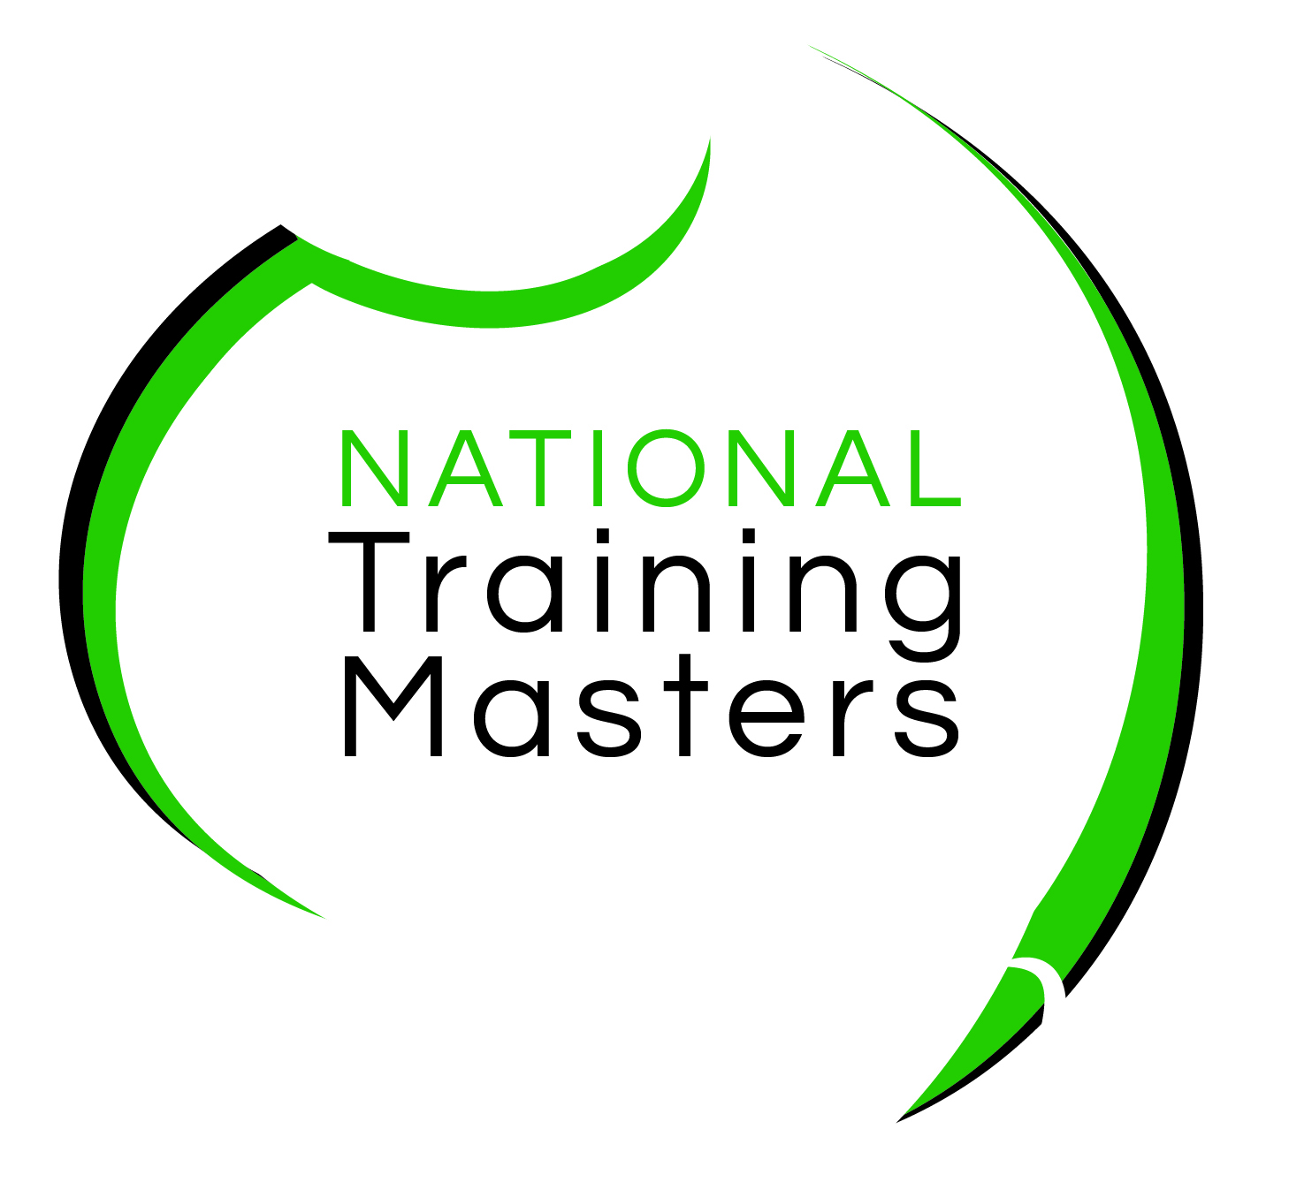
National Training Masters
Enrolment Form 2023
☐ ACM20121 Certificate II in Animal Care
☐ ACM30321 Certificate III in Wildlife and Exhibited Animal Care
☐ ACM30122 Certificate III in Animal Care Services

SECTION 1 – STUDENT DETAILS
Sections marked with * must be completed

Please PRINT clearly as this is how it will appear on your certificate. Please ensure that your details match with those of your Unique Student Identifier (USI). You must have a USI before you enrol, if you do not have one, visit: www.usi.gov.au to obtain your USI. Use the check boxes to indicate your responses ().

*Title: |  | *First Name |  |  |  |  | * Surname
* Gender:  ☐ Male ☐ Female ☐ Other |  |  |  | *DOB | (day) |  | (month) |  | (year)
* Email address
*Phone no (student mobile) |  |  |  |  |  |  | (Student Home)
* Residential address - Street number and name

* Suburb |  |  |  |  |  | *State |  | *Postcode
Identification (Please TICK that you hold a NSW Driver’s License and TICK the colour of your Medicare Card)

- NSW DRIVERS LICENSE ☐
- Drivers License from another state ☐
- Australian citizen, resident, New Zealand Citizen or eligible visa holder
You Medicare card colour proves your residency status.
Medicare Card, please select card colour: ☐ Green ☐ Yellow ☐ Blue

First day of class your trainer may sight your identification documents (Drivers License and Medicare Card) these personal documents will not be stored by NTM.
*Unique Student Identifier

From 1 January 2015, National Training Masters can be prevented from issuing you with a nationally recognised VET qualification or statement of attainment when you complete your course if you do not have a Unique Student Identifier (USI). If you have not yet obtained a USI you can apply for it directly at www.usi.gov.au on a computer or mobile device
Enter your USI here:

SECTION 2 – EMPLOYMENT and CURRENT STUDY
* Which of the following best describes your current employment and current study status?
(select one only)
☐ Full-time employee ☐ Unemployed - seeking full-time employment
☐ Part-time or casual employee ☐ Unemployed - seeking part-time or casual work
☐ Self-employed - not employing others ☐ Not employed - not seeking employment
☐ Employer ☐ Employed - unpaid worker in a family business
SECTION 3 - LANGUAGE and CULTURE
* In which country were you born?  ☐ Australia  ☐ Other (please specify):  * What is your citizenship? | * Do you speak a language other than English at home?  ☐ No  ☐ Yes (please specify): ______________  If you ticked ‘Yes’  * How well do you speak English?  ☐ Very well  ☐ Well  ☐ Not well
* Are you of Aboriginal or Torres Strait Islander origin?
☐ No ☐ Yes, Aboriginal ☐ Yes, Torres Strait Islander
SECTION 4 - EDUCATION
* What is the highest level of schooling you have completed?  ☐ Year 12 or equivalent  ☐ Year 11 or equivalent  ☐ Year 10 or equivalent  ☐ Year 9 or equivalent  ☐ Year 8 or below  ☐ I am still attending school | * Have you completed any of the following qualifications:  ☐ No  ☐ Yes (please tick any applicable boxes)  ☐ Bachelor degree or higher  ☐ Advanced diploma or Associate degree  ☐ Diploma or Associate diploma  ☐ Certificate IV or Advanced certificate/technician  ☐ Certificate III or trade certificate  ☐ Certificate II  ☐ Certificate I
SECTION 5 - DISABILITY
* Do you consider that you have a disability?  ☐ No (continue to Section 6)  ☐ Yes  If you selected YES, do you require extra support with your study?  ☐ No  ☐ Yes (please indicate type of support) | * If you selected yes, please indicate which area?  ☐ Hearing/deaf  ☐ Physical  ☐ Intellectual  ☐ Learning  ☐ Mental health  ☐ Acquired brain injury  ☐ Vision  ☐ Medical condition, including chronic health conditions  ☐ Other: _________________________

SECTION 6 - REASON FOR STUDY
* Which of the following best describes your main reason for studying this course  (select one only)  ☐ To get a job  ☐ To get a promotion  ☐ To develop extra skills for my job  ☐ It’s a requirement of my job  ☐ To start my own business | ☐ To develop my current business  ☐ To change careers  ☐ It’s a pre-requisite for another course I want to do  ☐ For personal interest  ☐ To get skills for community/voluntary work  ☐ Other (please explain)
ASSISTANCE WITH ENROLMENT
If you would like any assistance with enrolment, payment options or would like to speak to a learning consultant, please contact us, details below:
Head Office: Level 1, 47 Manning Street, Kiama NSW 2533
Telephone: 1300 653 501
web: www.ntm.edu.au
e-mail: admin@ntm.edu.au
Mail: PO Box 4225, Pitt Town NSW 2756

*

PLEASE READ THE PRIVACY NOTICE AND STUDENT DECLARATION AND
SIGN SECTION 7 - ACKNOWLEDGEMENT
National Training Masters
Privacy Notice and Student Declaration
Before signing the enrolment form, take the time to read the terms and conditions of your enrolment contained in this declaration. Ensure you have read the Learner Handbook, containing a summary of all our policies and procedures.

Privacy Note
Under the Data Provision Requirements 2012, National Training Masters is required to collect personal information about you and to disclose that personal information to the National Centre for Vocational Education Research Ltd (NCVER).

Your personal information (including the personal information contained on this enrolment form and your training activity data) may be used or disclosed by National Training Masters for statistical, regulatory and research purposes. National Training Masters may disclose your personal information for these purposes to third parties, including:
- School – if you are a secondary student undertaking VET, including a school-based apprenticeship or traineeship;
- Employer – if you are enrolled in training paid by your employer;
- Commonwealth and State or Territory government departments and authorised agencies;
- NCVER
- Organisations conducting student surveys; and
- Researchers.

Personal information disclosed to NCVER may be used or disclosed for the following purposes:
- Issuing statements of attainment or qualification, and populating authenticated VET transcripts;
- facilitating statistics and research relating to education, including surveys;
- understanding how the VET market operates, for policy, workforce planning and consumer information; and
- administering VET, including programme administration, regulation, monitoring and evaluation.

You may receive an NCVER student survey which may be administered by an NCVER employee, agent or third-party contractor. You may opt out of the survey at the time of being contacted.

NCVER will collect, hold, use and disclose your personal information in accordance with the Privacy Act 1988 (Cth), the VET Data Policy and all NCVER policies and protocols (including those published on NCVER’s website at www.ncver.edu.au).

Student Declaration and Consent
I declare that the information I have provided to the best of my knowledge is true and correct. I consent to the collection, use and disclosure of my personal information in accordance with the Privacy Notice above

SECTION 7 - ACKNOWLEDGEMENT
☐ * I acknowledge that it is a condition of my enrolment that I abide by all National Training Masters policies and procedures. I hereby acknowledge that I have received and read the Learner Handbook, the Privacy Notice, the Request for Payment and Student Declaration information. I further acknowledge that when I enroll in a course with National Training Masters I may receive their regular email newsletter containing articles relevant to training as well as special enrolment offers from time to time. I may opt out from receiving these newsletters at any time. I declare that the information I have provided to the best of my knowledge is true and correct. I consent to the collection, use and disclosure of my personal information in accordance with the Privacy Notice above.

opt out here ☐ ☐ * Digital signature is acceptable for sending back via e-mail

Signature:________________________________________ Date:_________________________________

Parental Consent if under 18 years

Parent / Guardian Signature:…………………………………..
Parent / Guardian Name: ……………………………………
Email: …………………………………………….
Contact Mobile Number: ……………………………………

Parental/guardian consent is required for all students under the age of 18

Office Use Only

Student ID #
Invoice #
Certificate #

