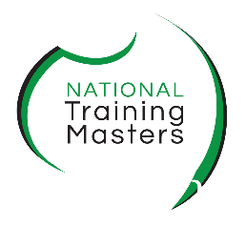
Complaints and Feedback Form
At NTM we value your feedback. Complete this form to provide either feedback or a complaint. You can also use this form to appeal against an assessment decision or final grade for a unit of competency or qualification. First, follow the steps under Complaints and Appeals in the Learner Guide to resolve any issues before using this form.
Send this form back to admin@ntm.edu.au. Next, we will provide you details on the steps to resolve your compliant, address your feedback or issue.
Your personal details
First Name |  |  |  |  | Last Name
Course |  |  |  |  | Mobile
Email
Details of your complaint or feedback
Have you discussed your matter with a staff member?

☐ Yes ☐ No Go to the next section
If yes when?
Who dealt with the matter?
What was the result?
Please give details of the complaint, feedback or issues and the outcome you are seeking
You may wish to attach further documentation
Signature |  |  |  |  | Date
Privacy notice: NTM collects personal information from you in order to deal with your compliant, feedback or issue. We deal with the information in accordance with NSW privacy legislation and NTM’s Privacy policy. For more information about privacy visit www.ipc.nsw.gov.au
Office use only
Management’s proposed solution:

Date student advised of proposed solution |  |  | ☐ Referred to Chief Executive Officer |  |  | ☐ Referred to independent third party
Click or tap to enter a date. |  |  | Click or tap to enter a date. |  |  | Click or tap to enter a date.
Resolved | ☐ Yes ☐ Referred: |  | CEO signature |  |  | Click or tap to enter a date.

