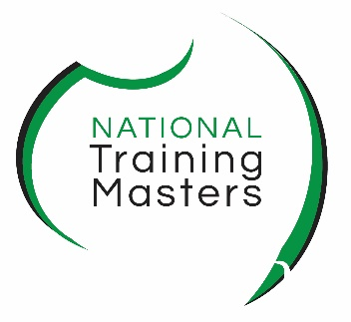
Student Digital Submission
Responsibility Form

Please complete this form as part of your orientation. Type in the form directly and sign, as a digital form your name is sufficient as a signature.
Course
First Name |  | Surname
Verified E-mail* the one you used to enrol
Plagiarism means using another person’s intellectual output and presenting it (without appropriate acknowledgement of the author or source) as one’s own.
Collusion means working with others without acknowledging each other in the completion of assessments.
Plagiarism and Collusion constitutes academic misconduct. Where there are reasonable grounds for believing that this has occurred, disciplinary procedures will be instituted.
I have read the Learner Guide policy on Plagiarism and Collusion (or have had this explained to me by my teachers) and understand the consequences of committing academic misconduct.
In good faith (Highlight Yes to acknowledge each statement)
Yes | I declare that my work will demonstrate my own knowledge, skills, and abilities.
Yes | I have taken proper and reasonable care to prevent my work from being copied by another student.
Yes | I give permission to NTM to reproduce my assessments and provide a copy to another member of staff our auditor for the purpose of cross checking, moderation, validation, and quality control purposes.
Yes | I give permission to authenticate my assessments, including submitting a copy to a checking/detection system that in turn may retain a copy of this work on a database for future checking.
Yes | I will reference my work to ensure compliance with copyright and intellectual property protection
Yes | I certify that all work will be my own and that I will not plagiarise the work of others or participate in collusion.
Yes | I will maintain and protect my Microsoft Account and OneDrive containing course content.
Yes | I will ensue I have virus protection on my digital devices and acknowledge that NTM is not responsible for any weblinks or files outside of NTM’s domain.
Yes | I am responsible for backing up my work to multiple device/options: such as pock drive, PC, USB and/or cloud.
Yes | I will retain a copy of my completed work as submitted for assessment.
Yes | I will use Teams and my verified email address for assessments and all communication with NTM.
Yes | I will carefully read the assessment criteria and submission requirements for each assessment.
Yes | I will reference any AI research tools such as Chat GPT or other tools when researching and completing assessments
Yes | I certify that the statements I have attested to above have been made in good faith and are true and correct. For statements you do not certify leave unhighlighted. Upload this form to Teams > Assignments
Date |  |  | Date
Your Name |  |  | Trainer Name

