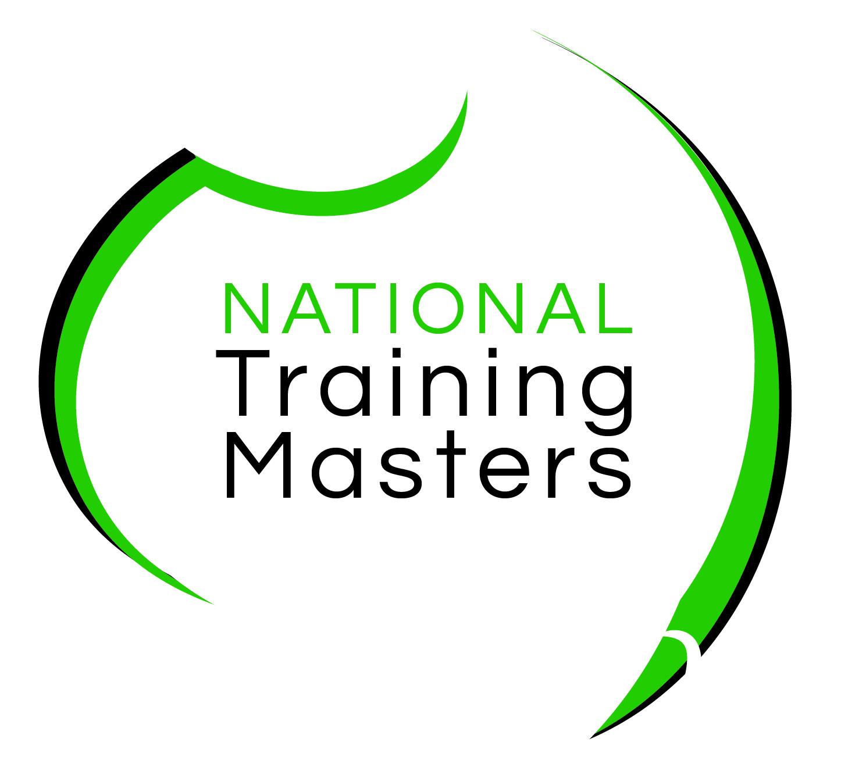
National Training Masters
Agreement to Borrow and
Release of Liability

I, ___Click or tap here to enter text.___________________, am borrowing the following
equipment from National Training Masters:

Equipment Description: Click or tap here to enter text.

Equipment # Click or tap here to enter text.

Conditions of Borrowing:
The Borrower acknowledges that the equipment borrowed:
☐ Is the property of the National Training Masters
☐ Is not covered by our insurance policy whilst in the borrower’s care, except the transportation directly from our office to and from the borrower’s home
☐ Was despatched from National Training Masters in good condition.

During the period the equipment is in their care, the borrower consequently agrees to:
☐ Keep the equipment in good order, ensuring no physical damage occurs
☐ Use the equipment only for the completion of course tasks and assessments
☐ Not load any other programs or games onto the equipment
☐ Return the equipment to our office in good condition by the designated date
☐ Use the equipment in accordance with the manufacturer’s operations manual

In the event that the equipment is lost or stolen, our office will need to purchase replacement equipment of similar type. The borrower agrees to reimburse our office for the cost of this replacement equipment.
In the event that the equipment is returned in a damaged state, the borrower agrees to reimburse our office for the cost of repairs.
I have read the Agreement above and will abide with the stated conditions:

_____________________________________ ____________________________________
Student Name Date

