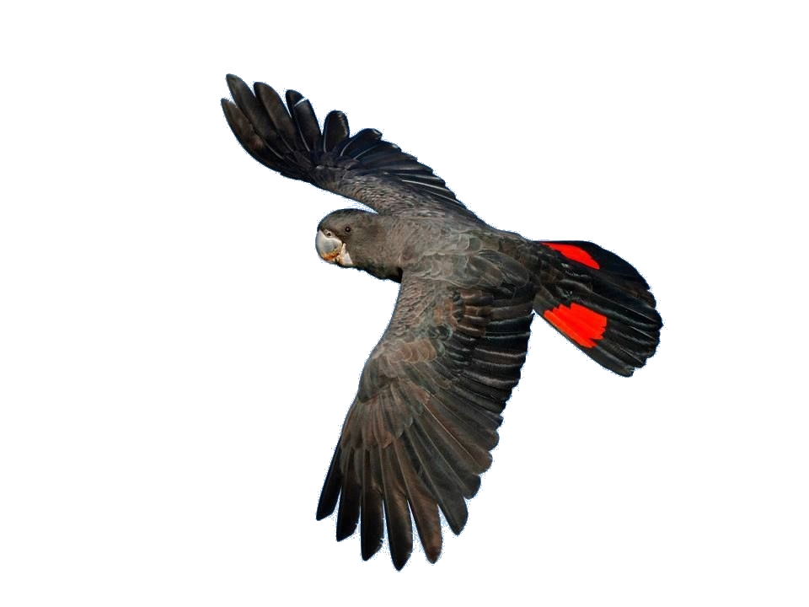
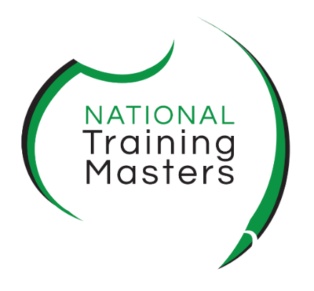
ntm.edu.au
ACM30321
Certificate III in
Wildlife and
Exhibited Animal Care
2026 | Application Pack

️Ensure you open this application pack in Microsoft Word, not on your mobile or a web browser! Also, do not print, handwrite, and then scan this form back; complete it electronically.
When you are accepted into the course, this pack also serves as your enrolment form!
Complete your personal details.
Name |  | E-mail
Mobile |  | Date
️Disclaimer: Classes are subject to change depending on demand. You are guaranteed a place once you have returned a completed application pack & paid the deposit for your course. If your choice of class is full, we will offer you one on an alternate day.

,

Copyright © 2026 National Training Masters
This application pack has been developed by and remains the property of National Training Masters. Unauthorised use is in breach of the Intellectual Property rights of this document, and severe penalties may apply.

National Training Masters
Head Office
Level 1, 47 Manning Street
Kiama NSW 2533
www.ntm.edu.au
Phone: 1300 653 501
Email: admin@ntm.edu.au
RTO Name: Bombohill Pty Ltd, trading as National Training Masters
RTO Registration: 91284

VERSION CONTROL
Version # | Date | Reason | Author
1.0 | 23.07.2025 | New Training Package ACM20121 | Jane Lees
1.1 | 02.10.2025 | Minor formatting changes | Jane Lees
2.0 | 14.12.2025 | Inclusion of PTA and major changes | David Michal Lipták
3.0 | 03.01.2026 | LLND changes and new Standards for RTO2 2025 | Jane Lees
4.0 | 05.06.2026 | Harmonisation with pre-training assessment and VSL | David Michal Lipták
4.1 | 26.06.2026 | Moderation with Animal Care Faculty Director | Brad Walker and Bayley Hynds

Table of Contents

Table of Contents 3
Application Outline 4
ACM30321 Certificate III in Wildlife and Exhibited Animal Care – this is Stage 1 of 3 4
The Application Process 5
Stage 1: Background Information 6
Personal details 6
Language and cultural diversity 6
Disability 7
Previous and Current Education and Training 8
Your education at school 8
Post-secondary education 8
Qualifications and certificates * 9
Work experience * 9
Recognition of Prior Learning 9
Employment 10
History of Violence 10
Stage 2: Pre-training assessment (PTA) 11
Using computer technology: digital literacy 13
Demonstrating your education level 14
Language, Literacy, Numeracy and Digital Literacy Quiz 15
Privacy Notice and Student Declaration 19
Signing your enrolment form 20
Your checklist for enrolling in the course 21
Emailing this pack and attachments to NTM is stage 3 of the process. 21
What happens in stage 4 of the application process? 21

Application Outline

ACM30321 Certificate III in Wildlife and Exhibited Animal Care – this is Stage 1 of 3

Welcome to National Training Masters (NTM).
Thank you for enquiring about the ACM30321 Certificate III in Wildlife and Exhibited Animal Care (WEAC) course.
You will need to complete this pack as part of the enrolment process. This intake will require you to complete three stages:
Stage 1: Complete this application pack.
Stage 2: You will undertake a Pre-Training Assessment (PTA) to demonstrate you meet the educational requirements and undertake a Language, Literacy, Numeracy and Digital Skill quiz.
Stage 3: Email this completed application pack to admin@ntm.edu.au, along with any certificates, transcripts, completion of year 12 or higher and evidence of access to a wildlife or exhibited animal care workplace one day a week.
If NSW Smart and Skilled funding is available, we will email you our form at stage 3 to complete and return. NSW Smart and Skilled funding is not always guaranteed, but if it is available, it will be offered to you. If not available, after you accept your course offering, we will issue an invoice for the $500 deposit due by the start of the course.
Stage 4: Once reviewed and approved, you will receive our Course Offer Letter for you to accept or decline your course offering.
If you have any questions before, during or after this intake process, or if you have difficulties filling out the application pack, don't hesitate to get in touch with our office on 1300 653 501 or admin@ntm.edu.au. We will then organise for an Animal Care trainer to speak with you and assist you in completing the pack.

Kind regards

Jane Lees
CEO

The Application Process
All applicants for the ACM30321 Certificate III in Wildlife and Exhibited Animal Care must complete the application pack. You must have a 12-year-or-higher equivalency; if not, you will be asked to complete a Language, Literacy, Numeracy and Digital Skills (LLND) quiz. Please note that the quiz is only used to help us assess your learning needs and whether you might need extra support during your course. Once completed, our Administration team will review your application, and if we require any further information, we will contact you via telephone or email to discuss.
Entry Requirements – check the website for the latest information https://www.ntm.edu.au/acm30321-certificate-iii-in-wildlife/
There are no entry requirements to undertake ACM30321 Certificate III in Wildlife and Exhibited Animal Care. However, some units of competency will require you to have access to a wildlife or exhibited animal care workplace one day a week.
To be prepared for this course, we strongly recommend that you meet the following:
- Completion of Certificate II in Animal Care or similar, or currently working in the industry.
- Reasonable level of fitness to handle animals and carry out manual lifting.
- A calm and patient demeanour
- The ability to provide your own Personal Protective Equipment (PPE), which may include covered non-slip shoes, full-length trousers, sleeved tops, a hat and sunscreen.
- Year 12 level of Language, Literacy, Numeracy and Digital Skills (LLND) or higher.
- Have capable digital literacy skills, including using a range of Microsoft products, such as Word, researching online, navigating the internet, making recordings at the animal facility and uploading these to Teams. Your teacher will provide support in using Microsoft products during your course.
- Possess strong English communication and presentation skills.
- Own or have access to a Windows 11 (which we highly recommend) or the latest Mac OS (Operating System) laptop for use in class, and reliable internet at home or work. We will provide you with access to the free education version of Office 365 (including Word and PowerPoint), so you do not need to purchase a subscription.
Completing the application pack will help us ensure the course is right for you and customise your learning program.
️You must complete the application; not a spouse, family member or someone from work. We use this application as part of the eligibility process.

Stage 1: Background Information
Instructions: Complete all questions. The NSW and Federal Governments require background information for both the application process and enrolment. Watch here to see why accurate details are so important. If your workplace is sending you for training, it is essential that you, as the applicant, complete these details. You must complete this form electronically and send it back to admin@ntm.edu.au. If you are using a smartphone or tablet, download Word to complete this form. Activate the checkboxes to indicate your responses (x). Anything with an asterisk* is required by the Government.

Personal details
1. Contact details*
First Name |  |  |  | Family Name:
Date of Birth |  |  |  | Age:
Gender | ☐ Female |  |  | ☐ Male | ☐ Other
Home Phone |  |  |  | Work Phone
Mobile
Email
Residential
Address
Postal Address
Suburb |  |  | Postcode |  | State:
Unique Student Identifier (USI)
From 1 January 2015, National Training Masters cannot issue you with a nationally recognised VET qualification or statement of attainment when you complete your course if you do not have a Unique Student Identifier (USI). If you have not yet obtained a USI, you can apply for it directly at http://www.usi.gov.au/ on computer or mobile device. Please note that if you would like to specify your gender as ‘other’, you will need to contact the USI Office for assistance. To find out more about the USI, watch the student video here. –

*Due to Government regulations, we are unable to process your enrolment without a valid USI.
USI * Mandatory
2. Identification (please activate either check box a. or b. (☒) and the colour of your Medicare Card in check box c.) * (Please do not send us copies of your Driver's License or Medicare Care card)
- NSW driver’s license ☐
- Driver’s license from another state or territory ☐
- Australian citizen, resident, New Zealand citizen, or eligible visa holder
Your Medicare card colour proves your residency status; we are not registered for international students.
Medicare Card, please select card colour: ☐ Green ☐ Yellow ☐ Blue

Language and cultural diversity
3a. In which country were you born? *
☐ Australia ☐ Other - please specify which country .........................................
3b. Are you an Australian Citizen? *
☐ Yes ☐ No - if No, are you a permanent resident ☐ Yes
☐ No
4. Do you speak a language other than English at home? *
(If more than one language, indicate the one that is spoken most often)
☐ No, English only ☐ Yes, other – please specify which language ...............................
How well do you speak English?
☐ Very well ☐ Well ☐ Not Well ☐ Not at all
Do you require help with English?
☐ No ☐ Yes, please get in touch with the Administration for more information on English Support.
5. Are you of Aboriginal or Torres Strait Islander origin? *
(For persons of both Aboriginal and Torres Strait Islander origin, mark both ‘Yes’ boxes)
️We do not ask for evidence of Aboriginal or Torres Strait Islander origin; you can self-identify in accordance with NSW Government Guidelines.
☐ No ☐ Yes, Aboriginal ☐ Yes, Torres Strait Islander

Disability

6. Do you consider yourself to have a disability, impairment or long-term condition, including mental health and chronic health conditions?
☐ Yes * ☐ No (go to question 8)
️Please note that a disability may be temporary or permanent, including chronic health, medical or psychological conditions. Following government guidelines, you will need to provide evidence of your disability or medical condition. Evidence may include a letter from your doctor or health professional.
7. If you indicated the presence of a disability, mental health, impairment, long-term or chronic condition, please select the area(s) from the following list (You may indicate more than one area by activating the check boxes x):
☐ Not applicable, or
☐ Hearing/deaf
☐ Physical
☐ Intellectual
☐ Learning
☐ Mental health
☐ Acquired brain impairment
☐ Vision
☐ Medical condition
☐ Other - please specify .....................................

Do you require training support and/or assistance for this disability, impairment or long-term condition from a Teacher/Consultant?
☐ No ☐ Yes, please get in touch with the Administration for more information on Disability Support.

Previous and Current Education and Training

Your education at school
Please complete the following by activating the boxes or providing information where necessary x):
8. Which is the highest grade you finished at school? *
☐ never attended school
☐ Year 8 or below
☐ Year 9
☐ Year 10
☐ Year 11
☐ Year 12 / HSC (Higher School Certificate) / IB (International Baccalaureate) / TPC (Tertiary Preparation Certificate)
9. Are you still enrolled in secondary or senior secondary education (high school)? *
☐ Yes
☐ No

Post-secondary education

10. Have you completed any qualifications? * ☐ No ☐ Yes
11. If YES, then tick any applicable boxes):
☐ Statement of Attainment ☐ Certificate III ☐ Advanced Diploma
☐ Certificate I ☐ Certificate IV ☐ Bachelor’s degree or higher
☐ Certificate II ☐ Diploma ☐ Other: please specify
Tick the applicable boxes below to indicate where you obtained the above qualifications *:
☐ TAFE
☐ HSC VET Framework Course / TVET / VETiS (VET in Schools)
☐ Community College
☐ Private Training Provider
☐ University/Higher Education
☐ Overseas

Qualifications and certificates *
12. In the table below, please list any courses you have completed or are currently enrolled in at TAFE, a private VET college, a Community College, as part of an apprenticeship or traineeship, higher education or at a university. List your qualifications starting with the most recent.
Course Name | Institution | State/Country | Year Finished
Note: 2 attach certified copies of all transcripts from university / TAFE / RTO and any trade licences you have to this intake booklet.

Work experience *

13. Please list your previous/current work experience or employment history, including voluntary and paid work. Start with your current position:
Position/Job | Company/Organisation | Length of Employment | Full Time/  Part Time

Recognition of Prior Learning
14. Based on your relevant qualifications and work experience, would you like to apply for Recognition of Prior Learning (RPL)? Read more on what RPL is and how the process works: Recognition of Prior Learning - Department of Employment and Workplace Relations, Australian Government
☐ No,
☐ Yes, please get in touch with Administration on how to apply for RPL.

Employment
15. Which of the following best describes your current employment and current study status? (Please select only one.) *
☐ Full-time business employee ☐ Part-time
☐ Self-employed - not employing others ☐ Casual
☐ Employed - an unpaid worker in a family ☐ Employer
☐ Unemployed - seeking full-time employment. ☐ Not employed – not seeking employment
☐ Unemployed - seeking part-time or casual ☐ Student

16. Which of the following BEST describes your main reason for undertaking the course(s) for which you are registering: *
☐ To get a job ☐ I wanted extra skills for my job.
☐ To develop my existing business ☐ To get into another course of study
☐ To try for a different career ☐ For personal interest or self-development
☐ To get a better job or promotion ☐ To get skills for community/voluntary work
☐ It was a requirement of my job. ☐ Other reasons

History of Violence

17. Do you have any history of behaviours that may pose a risk to the safety or well-being of others?
This may include, but is not limited to, physical aggression, threats, harassment, stalking, or other behaviours that could impact another person’s physical or psychological safety. If you select “Yes,” a member of our team will contact you confidentially to discuss your circumstances. The information you provide will be used to support a safe and inclusive learning environment for all students and staff and to identify any appropriate supports for you.
☐ No
☐ Yes, contact Administration for a confidential discussion.

Stage 2: Pre-training assessment (PTA)
You must complete these 10 activities.
Instructions:
Foundation skills are the underpinning communication and employability skills required for participation in the workplace, the community and in adult education and training. A range of terms has been used to describe these skills in the past. Language, literacy, numeracy and digital skills, or LLND, is the traditional term for the ability to speak, listen, read and write in English, and to use mathematical concepts. Foundation skills are a new term used in Vocational Education and Training; think of it as loosely covering the range of skills needed to communicate at work, at home, and in the community.
In this part of the pre-training process, we will ask you a series of questions about your experience working or volunteering in animal care. There is also a section on using technology as the course at National Training Masters is completed electronically - we no longer print volumes of assessment and training material as part of our commitment to sustainable work practices.
️Write about 50 words per question – all applicants to complete. If you miss or skip an item, we will return the applications for you to complete. Do not use AI to assist you.
1. Why do you want to undertake the Certificate III in Wildlife and Exhibited Animal Care?

2. Detail three things you would like to learn, develop and take away from undertaking the course:

3. Who at work or home do you have access to and can support you throughout the course? (managers, colleagues, family members, friends working in the animal care industry, etc)

4. Would you like extra assistance with the course, such as a 1:1 tutorial and/or small group workshops? Detail what type of help you would like, such as assistance with writing, assignments, using computers, getting organised, etc.

5. What employment are you hoping to attain after completing this qualification?

6. How will undertaking the Certificate III in Wildlife and Exhibited Animal Care help you to achieve your medium and long-term goals? When answering this question include your personal, career plans and goals (about 100 words)

7. Are there any factors that could impact your education and training (for instance, isolation, health, family or personal circumstances)?
☐ No
☐ Yes (please detail below)
8. How did you hear about National Training Masters?:

9. How proficient are your digital literacy skills, such as navigating Windows / Mac OS, typing, navigating the internet, and managing folders and files?
☐ Great ☐ Good ☐ Average ☐ Ok ☐ Poor

PLEASE NOTE: You will need to use your own laptop or PC to take this course. Can you please confirm whether you use a:
☐ Windows 11 Microsoft (we highly recommend Windows 11)
☐ Mac OS / Apple
️We DO NOT recommend Chromebooks, and we highly recommend Windows 11 laptops, as Mac OS Laptops have significant compatibility issues with Microsoft 365 products.

10. You will need access to reliable Wi-Fi while doing this course – a minimum of 6Mbps for download and upload. Click https://fast.com/, then press Enter. The number that comes up will be your download speed. Now, click the box labelled “Show more info” to see your upload speed. Take a snipping of your screen and attach it to your application. Your snipping should look similar to the following, although your numbers will be different:

Paste your WiFi speed here:
️On a Windows device, press Windows + shift + S to use the snipping tool.

Using computer technology: digital literacy
You must complete questions 11-16.
How confident do you feel you can use the following computer technologies and programs? At NTM, the course is undertaken electronically, using Word documents for the assessments and the internet for research. For a free assessment of your digital literacy, visit Norstar Community College. Keep in mind that you will have access to a Microsoft Student account, which provides FREE access to Office 365, so if you enrol, don’t buy the software!
Activate by clicking the box x next to the statement that applies to your digital skills now:
11. Operating a Personal Computer (PC) or Mac: turning on the computer, logging in, opening applications, using a mouse, saving documents, etc.
☐ Very Confident ☐ Pretty Good ☐ Average ☐ Basic ☐ Would like help
12. Microsoft Word (or similar program such as Pages), such as formatting, inserting pictures, using headers/footers, version control, developer tab features, macros, etc....
☐ Very Confident ☐ Pretty Good ☐ Average ☐ Basic ☐ Would like help
13. Web browser (Safari, Edge, Google Chrome or equivalent), searching the internet, typing in web pages, using Google or Bing…
☐ Very Confident ☐ Pretty Good ☐ Average ☐ Basic ☐ Would like help
14. Email - sending and receiving e-mail through Hotmail, Gmail, Yahoo, Outlook, etc...
☐ Very Confident ☐ Pretty Good ☐ Average ☐ Basic ☐ Would like help
15. PowerPoint (or similar program such as Keynote), designing, formatting, inserting pictures, creating transitions, etc....
☐ Very Confident ☐ Pretty Good ☐ Average ☐ Basic ☐ Would like help
16. Video Conferencing using applications such as Skype, Zoom, FaceTime and Microsoft Teams
☐ Very Confident ☐ Pretty Good ☐ Average ☐ Basic ☐ Would like help

Demonstrating your education level
You must either demonstrate your academic level or complete the LLND quiz.
You must be able to demonstrate you meet the education entry requirements for the course by either meeting one or more Part A Criteria or undertaking a LLND quiz in Part B.
Activate the checkboxes (☒) that apply to you. If you meet one or more of the following academic levels, you will not need to complete the LLND quiz.
Part A: Completion of:
☐ Certificate II in Animal Care
☐ Any Certificate III, IV, Diploma or higher qualification, such as a bachelor’s degree
☐ Year 12 completion at school, such as the HSC, VCE, or your state or territory equivalent.
If you have met one or more of the academic levels, skip the LLND quiz and go to the Privacy Notice and Student Declaration.
or
Part B: undertaking the LLND quiz.
☐ No, I don’t meet any of the academic levels.
Otherwise, you can demonstrate your academic level by completing the LLND quiz in the next section.
️If you have met any of the education levels in Part A, remember you can skip the next section.

Language, Literacy, Numeracy and Digital Literacy Quiz
You must complete this section if you did not meet Part A of the Education Level
How to undertake this fun LLND quiz:
- This quiz will take about 20 minutes to finish.
- Ask you 10 numeracy and literacy questions related to the Animal Care industry.
- Check your skills at a Year 10 level.
- You may use a calculator to answer these questions.
- Do not use Artificial Intelligence (AI) or the internet to assist you.
- Work individually, do not have a friend, colleague or family member assist you.

- Section 1: Language and Literacy

1. The six words below are misspelt. Correctly spell each one in the column on the right:

- Heilthy
- Communnication
- Infecshion
- Treet
- Envirenment
- Servis

2. Name the type of bird shown in this picture. Select the correct response:

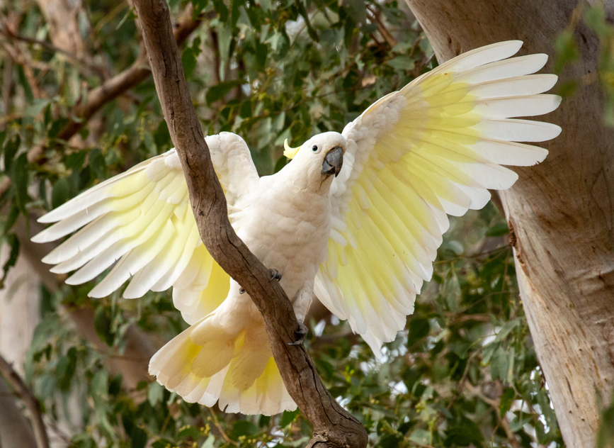 | ☐ Cockatiel  ☐ Budgies  ☐ Canary  ☐ Cockatoo

- 3. Zoe works for an animal grooming business. She has been asked to get a dog out of a cage, but the dog is behaving aggressively, curling its lip and growling. Select the best course of action for Zoe to take:

☐ Tell the dog to shut up and bang the cage.

☐ Ignore these signs, go into the cage, and pull it out by the collar.

☐ Ask for help from a senior person.

☐ Ignore the instruction and go and do something else.

4. The sign shown below means which of the following? Select the correct response:

 | ☐ There has been a chemical spill.  ☐ You need boots to walk through this area.  ☐ You must wear glasses to enter.  ☐ The floor is wet, and you may slip.

5. Read the text below and answer the following questions:
Wild dogs, like people, are social animals and live in a variety of social groupings, including pairs, family groups, non-breeding groups and “lone wolves”. Groups hunt cooperatively and, as they are social animals, conflicts within the group are minimised by a social structure.
This is termed a ‘social hierarchy,’ with dominant and submissive dogs within a group. By displaying several physical and behavioural characteristics, dogs demonstrate dominance or submission to other members of the group, which in turn defuses violence, injury or death of pack members.
When a dog shows submissive behaviour, the dominant dog’s aggression is ‘turned off’, thus sparing a fight and promoting cooperation and sociability within the pack. However, a submissive dog will exhibit aggressive behaviour if it is seriously threatened or is protecting a valuable resource.
Name four social groupings wild dogs may live in:

b What is the benefit of having a social structure for the group of dogs?

c How can dogs avoid fighting?

d Name something that will make a submissive dog show aggression:

Section 2: Numeracy
You must complete this section
1. Convert the following units of measurement:

a. 772g |  | kg
b. half a litre |  | ml
c. 250ml |  | L

2. You have been asked to mix up a cleaning solution for use in washing out the cat cages. The solution requires mixing 1100 ml of water with 300 ml of cleaning solution. What will the total volume of the cleaning solution be?

3. Suzanne runs a mobile grooming business. A client pays for a hydrobath for his dog. The hydro bath costs $12.50, and the owner gives Suzanne $20. How much change should Suzanne give the owner?

4. Kaiden works at a cattery where he is asked to weigh a cat in a pet carrier. The cat and carrier together weigh 4.7 kg. The carrier weighs 2.5 kg on its own. How much does the cat weigh?

5. Angela has been given the task of restocking the storeroom shelves and needs to have enough food to feed the cats in her area for three days. She has 28 cats in her care, and each cat eats half a can of food a day.
a How many cans would Angela need to have in stock?
b If each can costs $1.44, how much money would Angela need to purchase enough cans of food for all the cats?

Privacy Notice and Student Declaration
You must complete this section as part of your enrolment. Remember to read and sign the section at the end.
Before signing the application pack and sending it back, take the time to read the terms and conditions of your enrolment contained in this declaration. Ensure you have read the Learner Handbook, which summarises all our policies and procedures.

Privacy Notice
Why we collect your personal information
As a registered training organisation (RTO), we collect your personal information to process and manage your enrolment in a vocational education and training (VET) course.
If you elect not to provide us with your personal details, we will be unable to issue you with your qualification.
How we use your personal information
We use your personal information to deliver VET courses to you and, as needed, to comply with our obligations as an RTO.
How we disclose your personal information
We are required by law (under the National Vocational Education and Training Regulator Act 2011 (Cth) (NVETR Act)) to disclose the personal information we collect about you to the National VET Data Collection kept by the National Centre for Vocational Education Research Ltd (NCVER). The NCVER is responsible for collecting, managing, analysing and communicating research and statistics about the Australian VET sector.
We are also authorised by law (under the NVETR Act) to disclose your personal information to the relevant state or territory training authority.
How NCVER and other bodies handle your personal information
NCVER will collect, hold, use and disclose your personal information in accordance with the law, including the Privacy Act 1988 (Cth) (Privacy Act) and the NVETR Act. Your personal information may be used and disclosed by NCVER for purposes that include populating authenticated VET transcripts; administration of VET; facilitation of statistics and research relating to education, including surveys and data linkage; and understanding the VET market.
NCVER is authorised to disclose information to the Australian Government Department of Employment and Workplace Relations (DEWR), Commonwealth authorities, state and territory authorities (other than registered training organisations) that deal with matters relating to VET and VET regulators for those bodies, including to enable:
- administration of VET, including program administration, regulation, monitoring and evaluation
- facilitation of statistics and research relating to education, including surveys and data linkage
- understanding how the VET market operates, for policy, workforce planning and consumer information.
NCVER may also disclose personal information to persons engaged by NCVER to research on NCVER’s behalf.
NCVER does not intend to disclose your personal information to any overseas recipients.
For more information about how NCVER will handle your personal information, please refer to NCVER’s Privacy Policy at www.ncver.edu.au/privacy.
If you would like to access or correct your information, please contact NTM using the contact details below.
Administration via email admin@ntm.edu.au or call 1300 653 501.
The DEWR is authorised by law, including the Privacy Act and the NVETR Act, to collect, use and disclose your personal information to fulfil specified functions and activities. For more information about how DEWR will handle your personal information, please refer to the DEWR VET Privacy Notice at https://www.dewr.gov.au/national-vet-data/vet-privacy-notice.

Signing your enrolment form

I acknowledge that it is a condition of my enrolment that I abide by all National Training Masters policies and procedures. I hereby acknowledge that I have received and read the Learner Handbook, the Privacy Notice and the Student Declaration. I further acknowledge that when I enrol in a course with National Training Masters, I may receive their regular email newsletter containing training-related articles, as well as special enrolment offers from time to time. I may opt out of receiving these newsletters at any time. I declare that the information I have provided, to the best of my knowledge, is true and correct. I consent to the collection, use and disclosure of my personal information in accordance with the Privacy Notice above. I have read the section titled Management of Risk of Harm to Students and Staff in the NTM handbook. I also acknowledge that it is a condition of my enrolment to advise NTM if I have a history of violence.
Your name – sign or type your name here * | Date
❌

☐ I opt out of receiving emails and promotions from NTM.
Privacy Statement: This Application Pack is a confidential and controlled document. You may review this document by contacting the Administration.

Your checklist for enrolling in the course
You must complete this section
To ensure you have completed the application pack, use this checklist to assist you in finalising your documents (activate by clicking the box x) before sending them back to NTM. Completing all sections of this application pack is stages 1 and 2 of the enrolment process.

Stage 3: Emailing this pack and attachments to NTM

☐ Complete all sections in this application pack and make sure to sign the form.
☐ Attach certified copies of courses and transcripts from TAFE, RTO, University or other training providers.
☐ Attach evidence of your work placement in a zoological facility of at least 1 day per week, paid, or volunteer work. The evidence may be a letter or email from your workplace, attached as a separate PDF file. If you don’t yet have access to a wildlife facility organised, please note that you must have this by the end of the fourth week of your course.️ Without suitable workplace access, you will not be able to meet the course requirements.
☐ Email this Word document, plus all your transcripts and certificates, the snipping of your download and upload speeds, and your workplace evidence, to admin@ntm.edu.au

️ Save this document in Word (.doc or docx), do not convert to a PDF or print. Send other attachments such as certificates and transcripts as separate Word or PDF files, do not embed them here or zip the files!
What happens in stage 4 of the application process?
Once we receive your application, along with attachments including your LLND quiz (and any previous qualifications), you will receive a confirmation email confirming that your class position has been allocated. Your application will then be submitted to NSW State Training to assess your eligibility for any NSW Government Funding, if applicable. Once NTM have been notified by NSW State Training, we will advise you of the course cost and send you through our course offer letter to accept or decline your position in the class. If NSW Government funding is not available, we will issue an invoice, which will be emailed to you for payment of your $500 deposit before course commencement. Please discuss with our admin team if you require the offer letter earlier for work purposes. Once you have received our Offer Letter, we will require a reply email to ACCEPT or DECLINE the offer.
There is no obligation to enrol if you are offered a place.
If your application is unsuccessful, our Animal Care director will contact you to discuss options.
For confidential Counselling and Careers advice, you can contact the admin via email or phone to organise a free careers session.
️ Remember to send your completed application pack to admin@ntm.edu.au and keep a copy. If you have any questions, contact our office on 1300 653 501.

